

**Business Analysis**

**By: Shashwat Yadav**

Table of Content

1. Introduction
2. Methodology
3. Requirement Analysis
4. Visuals and their Insights
5. Conclusion

Introduction:

This introduction section provides an overview of the importance of understanding, outlines the purpose and scope of our analysis.

Performance: In the era of data-driven decision-making, data science has emerged as a critical field, with professionals playing a pivotal role in extracting valuable insights from vast amounts of data.

Labour Cost: Knowledge of labour cost trends enables the management to develop an appropriate compensation packages, strengthening their recruitment strategies.

Discount and Sales: Knowledge of Discount and Sales trends enables the management to develop an appropriate package, strengthening their profit making strategies and maintaining a competitive edge.

Limitations of the Dataset:

It is essential to acknowledge the limitations of the dataset. These limitations may include potential biases in data collection, sample representativeness, or missing data points. Additionally, the dataset's coverage may be specific to certain industries, regions, or data collection methodologies, limiting its generalizability. It is crucial to consider these limitations while interpreting the analysis results and drawing conclusions.

Methodology:

In this section, an overview of the methodology employed in the analysis of Business of Holman Motorcars is provided. Here I outline the data collection process, sources, discuss the data cleaning, and pre-processing techniques applied, and provide an overview of the variables analysed and their significance.

**Data Collection Process and Sources-**

For this analysis, we obtained the dataset from Online Excel File.

**Data Cleaning and Pre-processing Techniques Applied-**

To ensure the dataset's usability and accuracy, we performed a series of data cleaning and pre-processing steps. This involved identifying and converting data types to facilitate accurate analysis. Specific techniques applied include:

**Converting Data Types:** We assessed the data types of each variable and converted them as necessary to ensure accurate analysis. This involved converting numerical variables to the appropriate numeric data types for statistical computations.

**Overview of the Variables Analysed:**

The dataset comprises various variables that were analysed to gain insights into data science salaries. The key variables analysed are:

* Sales Price
* Cost Price
* Spare parts
* Labour Cost
* Vehicle Type
* Make
* Model
* Reporting Year
* Client Name
* Total Discount
* Country
* Invoice Date

Requirement Analysis:

There are three main Analysis for this particular business analysis:

1. Performance Analysis.
2. Labour Cost Analysis.
3. Discount and Sales Analysis.

Basically we have used Four Pages for this Analysis:

On Fist page we have “Cover Page” with three navigation boxes for above three Analysis Pages.

On Second Page we have Performance Analysis which contains “Performance Analysis of Luxury Automobiles in Europe and USA” – have Four different cards, For charts, one Table and a Slicer.

On Third Page we have “Labour Cost Analysis” which contains Five charts. Regarding labour.

On fourth and last page we have “Discount and Sales Analysis” which contains 4 charts regarding discount and sales.

Visuals and their Insights:

Business Analysis (Page-2):

Performance Analysis of Luxury Automobiles in Europe and US -

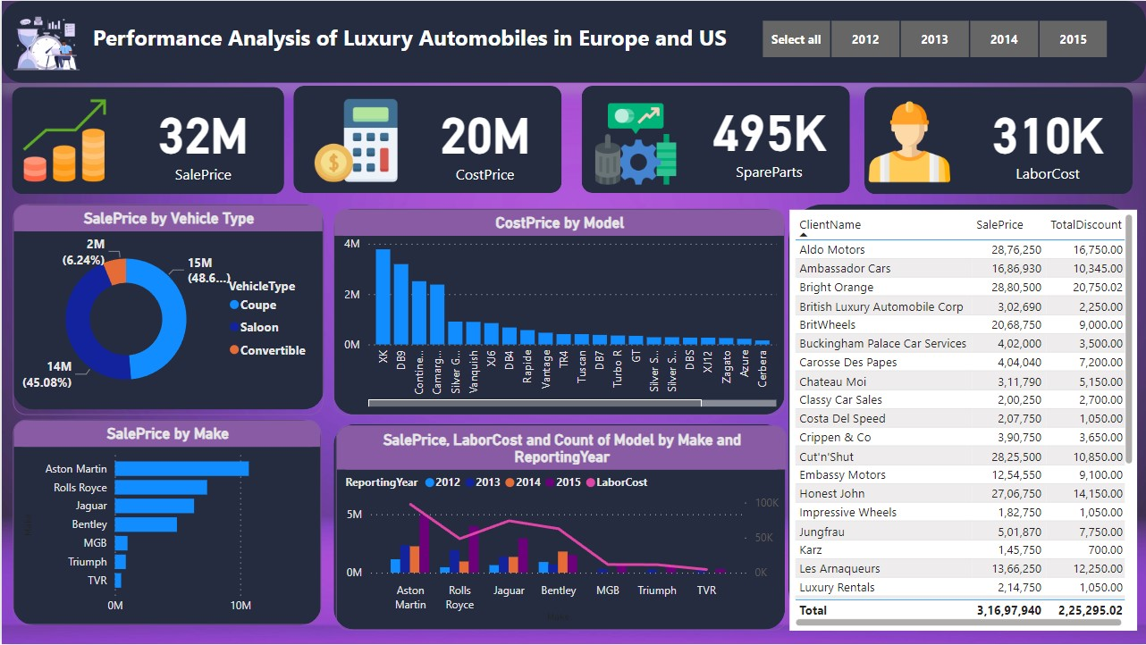

In this page as you can see there are 4-cards, 4-charts, 1-Table and a Slicer presented, now we will explain all the information we get from these data and visuals-

**4-Cards:**

|  |
| --- |
| First card presents us the total Sum of Sales Price. |
| Second card presents us the total Sum of Cost Price. |
| Third card presents us the Total Sum of Spare Parts. |
| Fourth card presents us the Total Sum of Labour Cost. |

**4-Charts:**

|  |
| --- |
| **First Chart is a Donut Chart containing the data of (Sale Price by Vehicle Type)** in which Vehicle type is given as legends in the chart and gives us the figures that Coupe type has 48.68% (1,54,31,090 $), Saloon type has 45.08% (1,42,90,150 $), Convertible type has 6.24% (19,76,700 $). |
| **Second Chart is a Clustered Column Chart containing the data of (Cost Price by Model)**  in which Cost Price is shown in Y-axis and Model is shown in X-axis giving the visuals through column that which model has the highest to lowest Sum of Cost Price. |
| **Third Chart is a Clustered Bar Chart containing the data of (Sales Price by Make)**  in which Sales Price is shown in X-axis and Make is shown in Y-axis giving the visuals through bar that which make has the highest to lowest Sum of Sales Price. |
| **Fourth Chart is a Line and Clustered Column Chart containing the data of (Sales Price, Labour Cost and Count of Model by Make according to Year)** in which Make is shown in X-axis, Sales Price is shown in Column Y-axis, Labour Cost is shown in Line Y-axis and Reporting year given as Column Legends hence giving the visuals. |

**1-Table:**

|  |
| --- |
| **Fifth Visual is a Table containing the data of (Client Name, Sales Price and Total Discount)** in which the Table shows us the Client wise Sum of Sales Price and Sum of total Discount for the particular client as well as the Total Sum of Sales Price and Total Discount at the bottom of the Table. |

**1-Slicer:**

|  |
| --- |
| It is a Slicer given at the Top Right Corner of the page in this Reporting Year is given by which we can filter out all the other data as well as change their visuals on the basis of year. |

Business Analysis (Page-3):

Labour Cost Analysis of Luxury Automobiles in Europe and US –

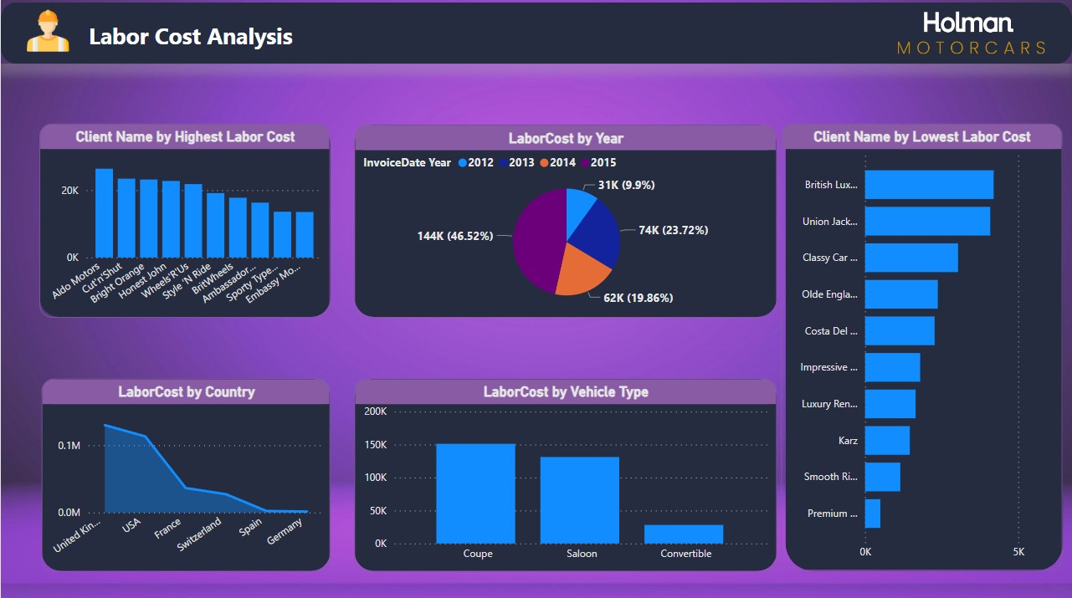

In this page as you can see there are 5-charts, now we will explain all the information we get from these data and visuals-

**5-Charts:**

|  |
| --- |
| **First Chart is a Clustered Column Chart containing the data of (Client Name by Highest Labour Cost)** in which Client Name is shown in X-axis and Labour Cost is shown in Y-axis, also there is a filter used to show the top 10 Client Name which are top 10 according to the data in Sum of Labour Cost and giving the visuals through column. |
| **Second Chart is a Pie Chart containing the data of (Labour Cost by Year)** in which invoice Date Year is given as legends in the chart and gives us the figures that in 2012 Labour Cost was 9.9% (30,748 $), in 2013 Labour Cost was 23.72% (73,655 $), in 2014 Labour Cost was 19.86% (61,662 $), in 2015 Labour Cost was 46.52% (1,44,433 $) of all the 4 Years Labour Cost. |
| **Third Chart is an Area Chart containing the data of (Labour Cost by Country)** in which Labour Cost is shown in Y-axis and Country is shown in X-axis giving the visuals through area, which Country has the highest to lowest Sum of Labour Cost. |
| **Fourth Chart is a Clustered Column Chart containing the data of (Labour Cost by Vehicle Type)** in which Labour Cost is shown in Y-axis, Vehicle Type is shown in X-axis hence giving the visuals of three Columns of Coupe having(1,51,185 $), Saloon having(1,31,175 $) and Convertible having(28,138 $). |
| **Fifth Chart is a Clustered Bar Chart containing the data of (Client Name by Lowest Labour Cost)**  in which Client Name is shown in Y-axis and Labour Cost is shown in X-axis, also there is a filter used to show the Bottom 10 Client Name having bottom 10 according to the data in Sum of Labour Cost and giving the visuals through Bar. |

Business Analysis (Page-4):

Discount and Sales Analysis of Luxury Automobiles in Europe and US –

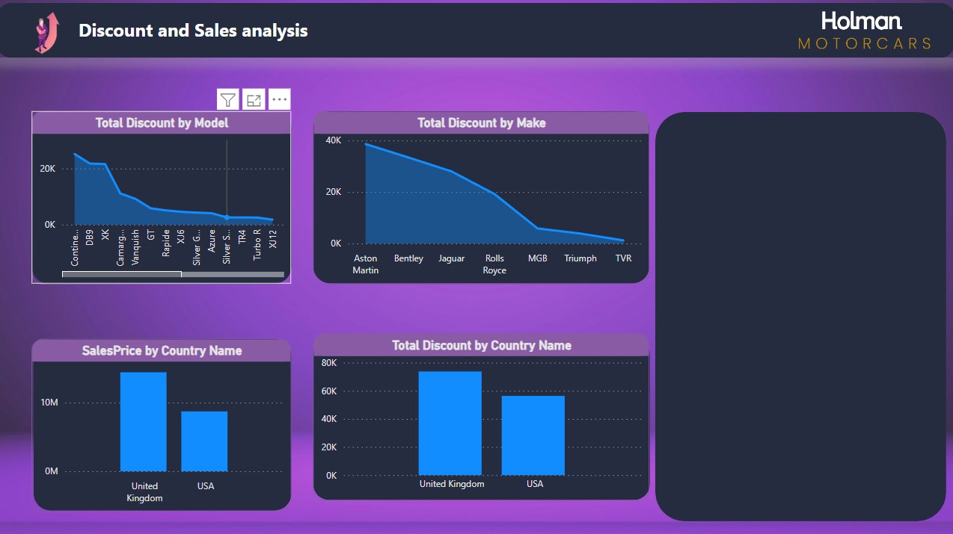

In this page as you can see there are 4-charts, now we will explain all the information we get from these data and visuals-

**4-Charts:**

|  |
| --- |
| **First Chart is an Area Chart containing the data of (Total Discount by Model)** in which Total Discount is shown in Y-axis and Model is shown in X-axis giving the visuals through area, which model has the highest to lowest Sum of Total discount given. |
| **Second Chart is an Area Chart containing the data of (Total Discount by Make)** in which Total Discount is shown in Y-axis and Make is shown in X-axis giving the visuals through area, which Make has the highest to lowest Sum of Total Discount given. |
| **Third Chart is a Clustered Column Chart containing the data of (Sales Price by Country Name)** in which Sales Price is shown in Y-axis, Country Name is shown in X-axis hence giving the visuals of two Columns of United Kingdom having(1,44,21,750 $) and US having(87,21,830 $) of sum of Sales Price. |
| **Fourth Chart is a Clustered Column Chart containing the data of (Total Discount by Country Name)** in which Total Discount is shown in Y-axis, Country Name is shown in X-axis hence giving the visuals of two Columns of United Kingdom having(73,750.02 $) and US having(56,395.00 $) of sum of Total Discount. |

Conclusion:

* Total Sales Price –Apporx. 32M
* Total Cost Price – Aprrox. 20M
* Total Spare Parts – Aprrox. 495K
* Total Labour Cost – Aprrox. 310K
* Coupe type has 48.68% (1,54,31,090 $) Sales Price
* Saloon type has 45.08% (1,42,90,150 $) Sales Price
* Convertible type has 6.24% (19,76,700 $) Sales Price
* Top 5 Makers according to Sales Price are: (Total Sum of Sales Price)

1. Aston Martin – 1,06,86,040 $
2. Rolls Royce – 73,56,900 $
3. Jaguar – 63,19,000 $
4. Bentley – 49,51,250 $
5. MGB – 10,11,000 $

* Top 5 Models according to Cost Price are: (Total Sum of Cost Price)

1. XK – 37,81,300 $
2. DB9 – 31,93,180 $
3. Continental – 25,12,100 $
4. Camargue – 23,79,105 $
5. Silver Ghost – 9,07,560 $

* UK has the highest Labour cost – 1,29,952 $
* Aldo Motors has highest labour cost – 26,380 $
* Coupe type has highest labour cost – 1,51,185 $
* Client has lowest labour cost – British Luxury Automobile Corp. (4,199 $)
* Highest sum of discount given on Continental model – 25,200.00 $
* Highest sum of discount given by maker on Aston Martin – 38,645.02 $
* Total sum of discount given in UK -73,750.02 $
* Total sum of discount given in US -56,395.00 $

These figures are only showing the data without applying any filters it may change on the basis of filters given in the slicers on the dashboard and will also changes the visuals of the data.